**CREATE AN IAM USER GIVING FULL S3 ACCESS**

**Click on the search field and type “IAM” in the search field**

**Visit** **aws.amazon.com** **and Sign in**

**1.….**.

**2.**

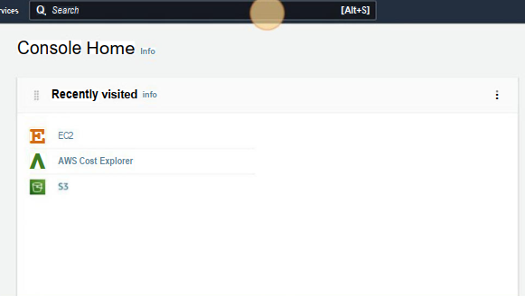

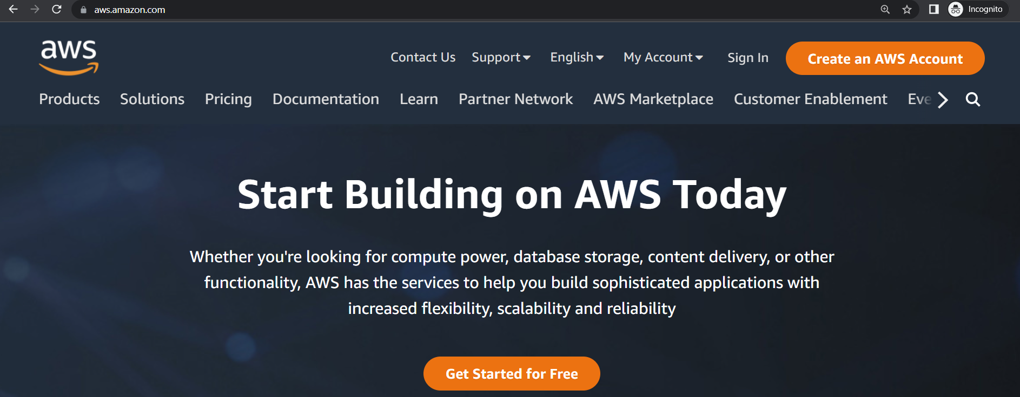

**Click on “Users”**

**Click on “IAM”**

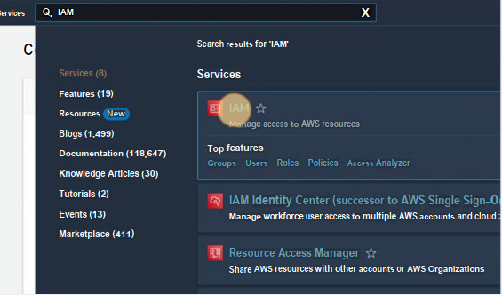

**s**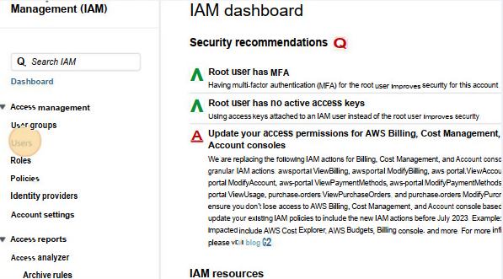

**3.**

**4.….**.

**Click on “Add users”**

**Enter the user name and click on the checkbox to provide user access to AWS Management Console**

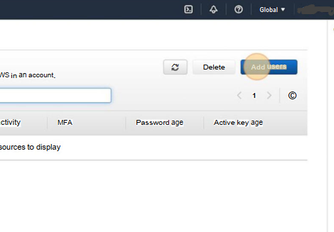

**5.….**.

**6.….**.

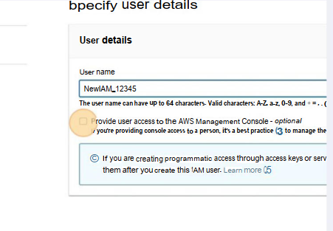

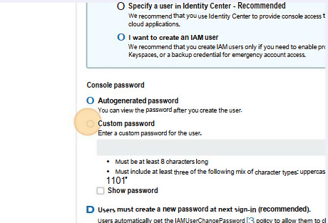

**Set the password and click the checkbox “Users must create a new password at next sign-in”**

**Select “I want to create an IAM user” as well as “custom password”**

**8.….**.

**7.….**.

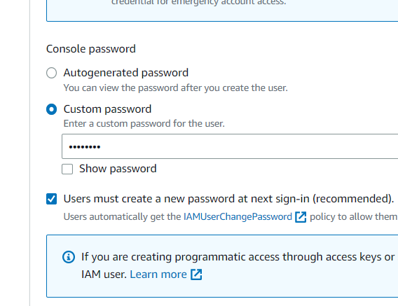

**Click on “Next”**

**Click on “Create group”**

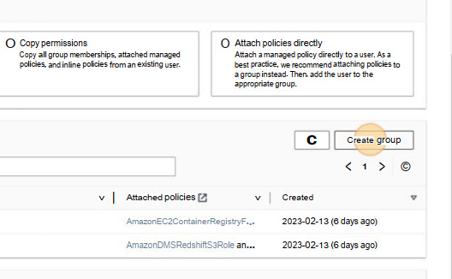

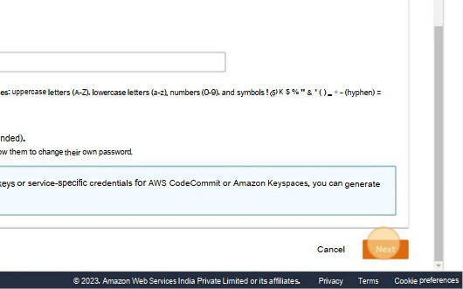

**10.….**.

**9.….**.

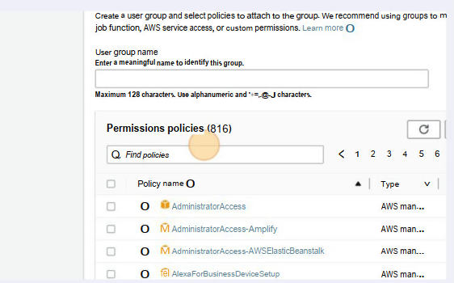

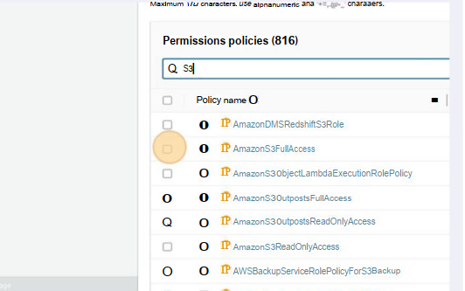

**Click the checkbox “AmazonS3FullAccess”**

**Click the “find policies” field and type “S3”**

**12.….**.

**11.….**.

**Enter a user group name**

**14.….**.

**13.….**.

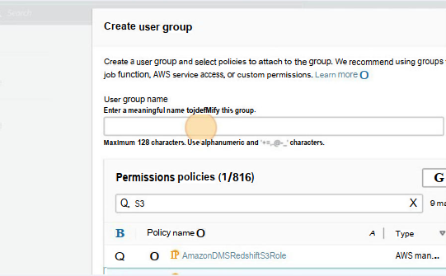

**Click on “Create user group”**

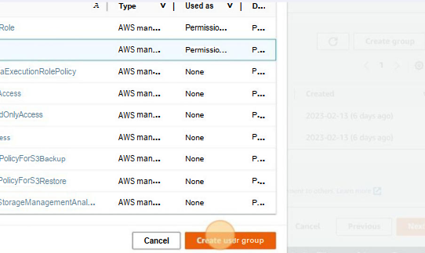

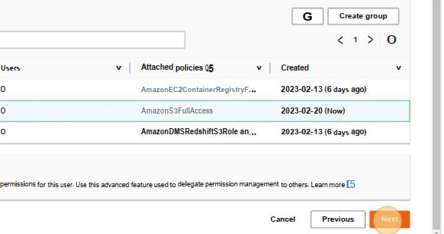

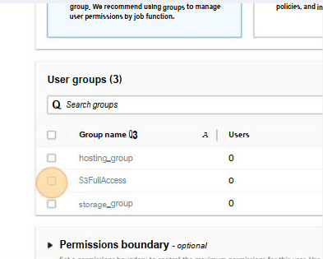

**Click on “Next”**

**16**.

**15**.

**Click on the checkbox “S3FullAccess”**

**Click on “Create user”**

**Click on “Download .csv file”**

**18.….**.

**17.….**.

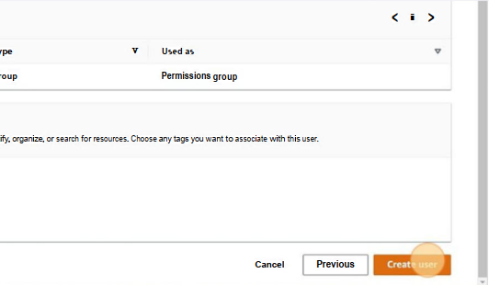

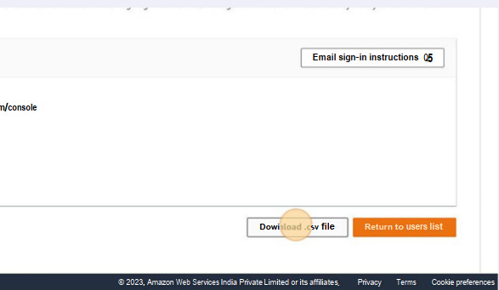

**17.….**.

**IAM user is thus created**